Fast**National University of Computer & Emerging Sciences, Karachi  
Fall-2020 CS-Department  
Assignment 3**

**Deadline 4 April 2020 11:55 pm**

|  |  |
| --- | --- |
| **Course Code: CS301** | **Course Name: Theory of Automata** |

**Question 1: CFG**

**Construct a CFG which generates the following languages:**

1. **L1 ={ anbn|n≥1}**



1. **L2 ={ anbman|n≥1}**

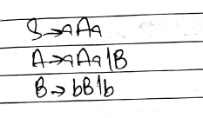

**Question 2: CFG**

***A grammar  G which is context-free has the productions*  
  
*S → aAB*  
*A → Bba*  
*B → bB*  
*B → c*****Give the derivation and parse tree for the word w=acbabc.**

**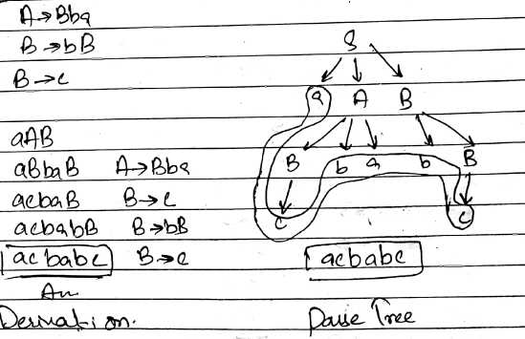  
Question 3:**

***A CFG given by productions is  
  
S →  aSb  
S → ab***

***Obtain the Language generated by L(G).***

***solution :aabb,aaabbb,aaaabbbb,…***

**anbn *n>=2***

**Question 4:**

**A CFG given by productions isS →  aBS →  bAA →  aSA →  aAAA →  aB →  bSB →  aBBB →  bobtain the leftmost derivation and rightmost derivation for the string “aaabbabbba”**

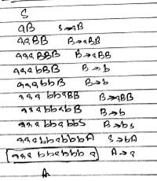 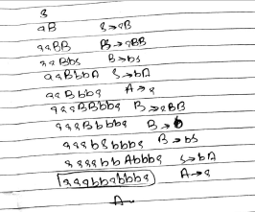

**Question 5:**

**Prove the grammar is ambiguous S →  a | aAb | abSbA →  aAAb | bS**

**Note : here you can suppose a string of your own wish ,but it belongs to language.**

solution : String aaAAbb -> aabSbSbb -> aabababb

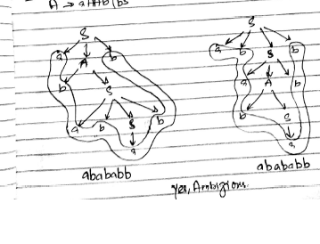

**Question 6:**

**Prove the grammar is ambiguousS →  aB | abA →  aAB | aB →  ABb | b**

**Note : here you can suppose a string of your own wish ,but it belongs to language.**

***solution :***

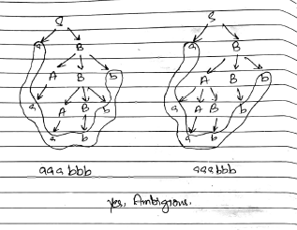

**Question 7:**

***Obtain a grammar in Chomsky Normal Form (CNF) equivalent to the grammar G with productions P given*  
  
*S →  aAbB*  
*A →  aA| a*  
*B →  bB | b***

***solution :***

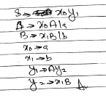

**Question 8: *Convert given CFG to CNF***

***S ->ASA |aB***

***A -> B |S***

***B ->b |є***

solution :

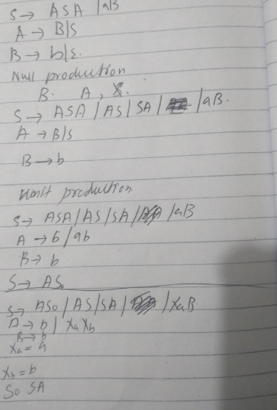

***BEST OF LUCK!***